1. **Setting up Gmail account**

All group need to create a new gmail account for that follow the below steps:

1. **Turned On 2-step verification process for above Gmail- Account**

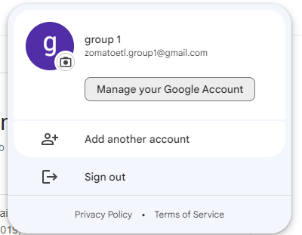

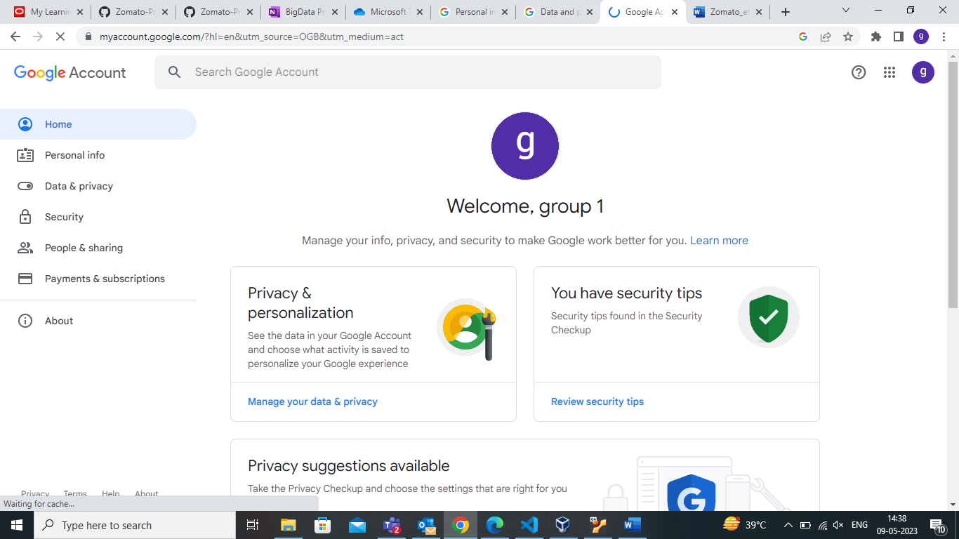

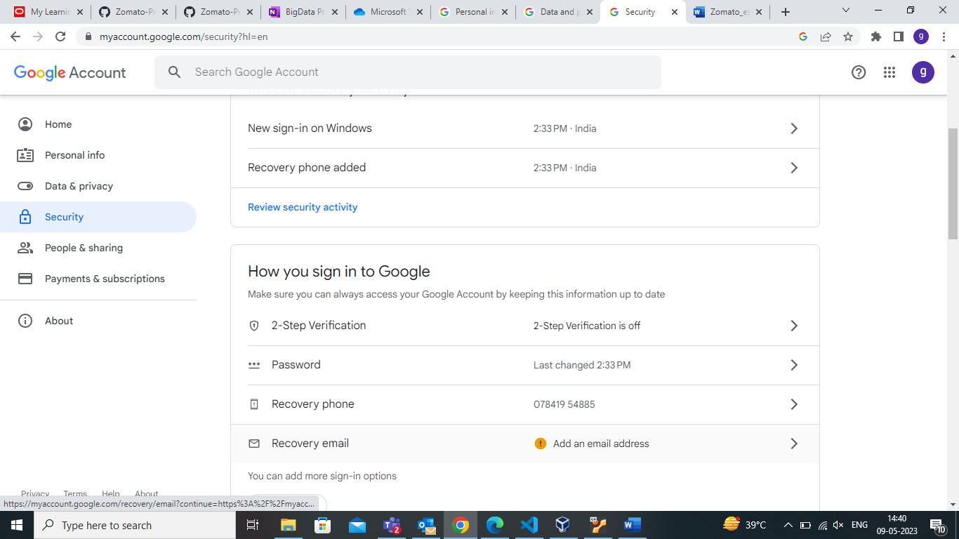

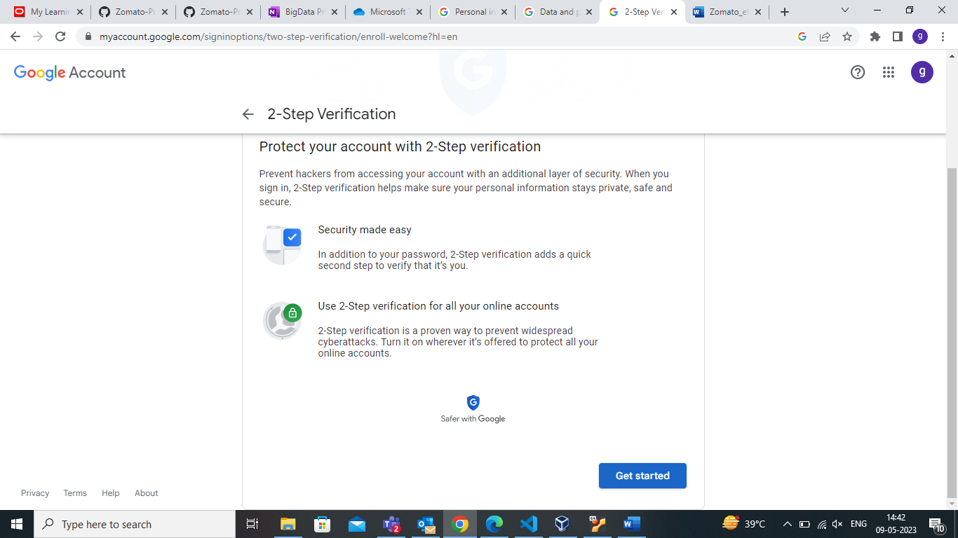

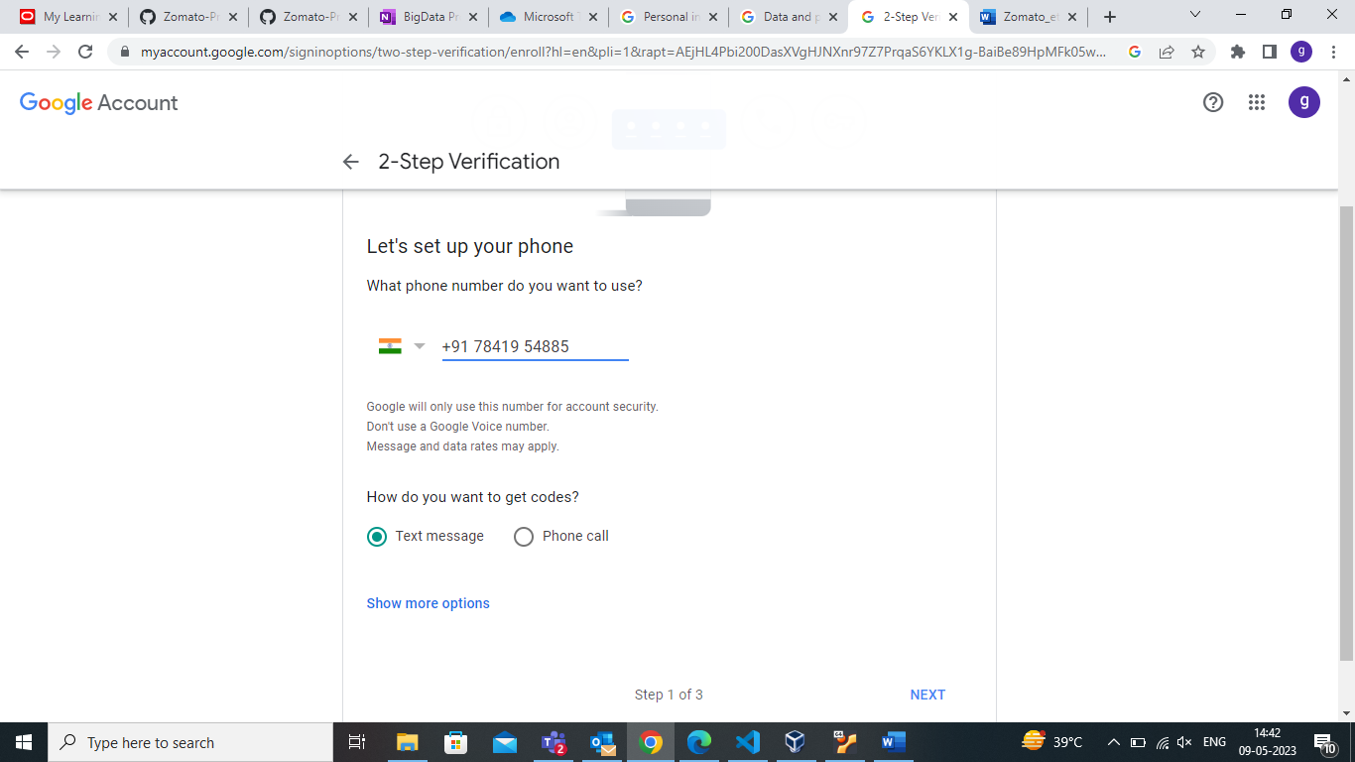

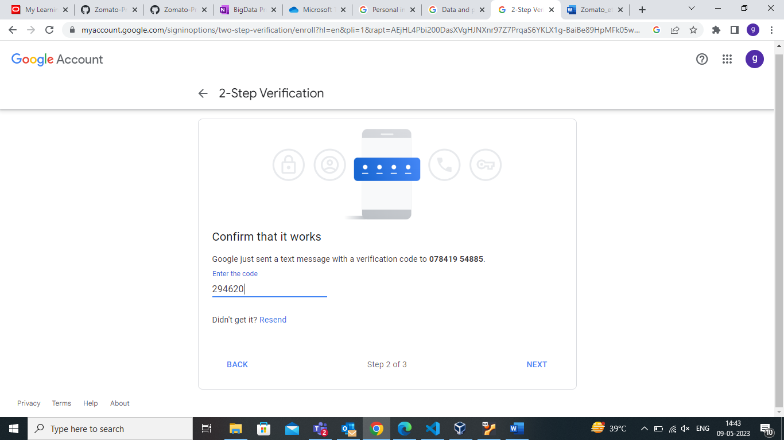

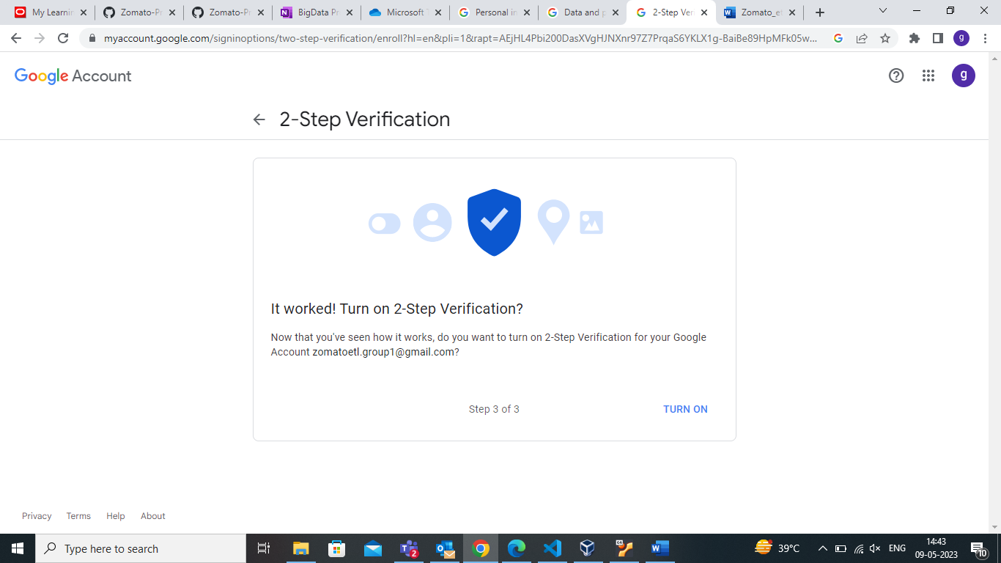

1. **Creating Google Application and setting the password**

For creating an application go to the link attached below:

<https://myaccount.google.com/u/4/apppasswords>

And follow the steps :

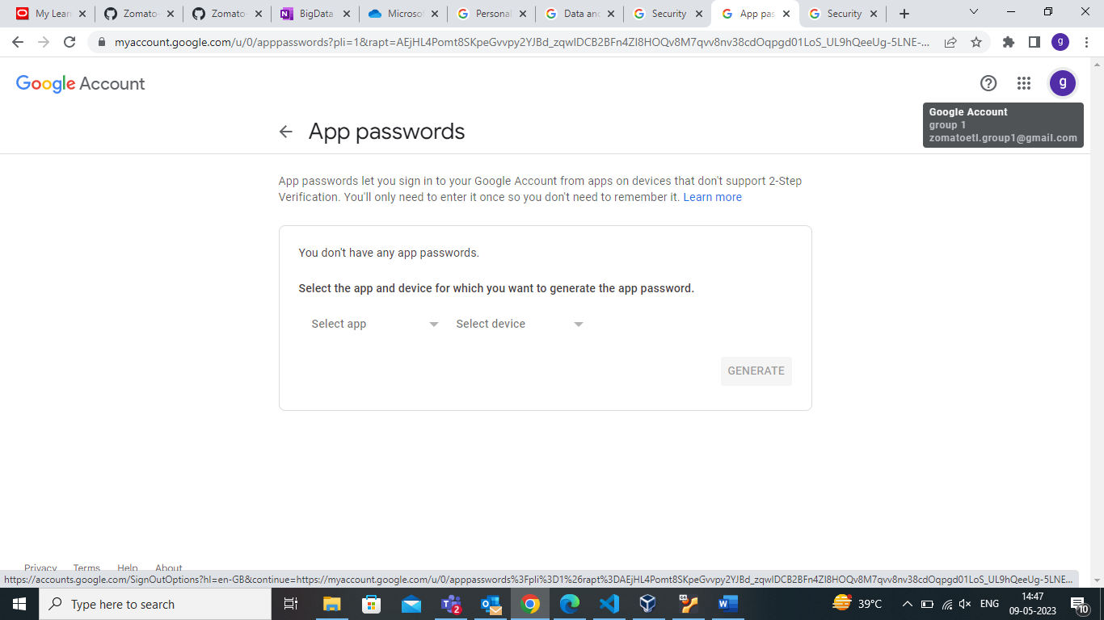

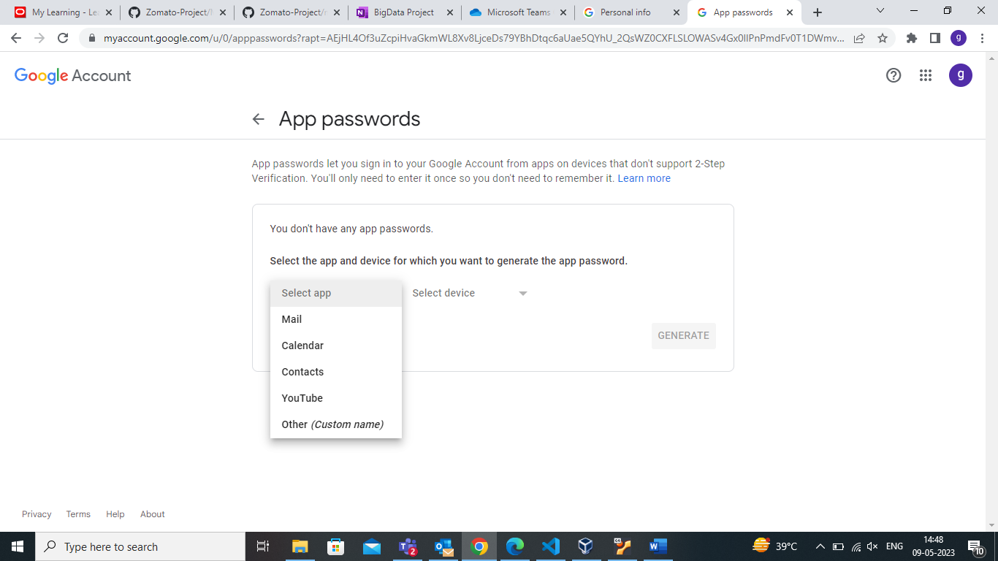

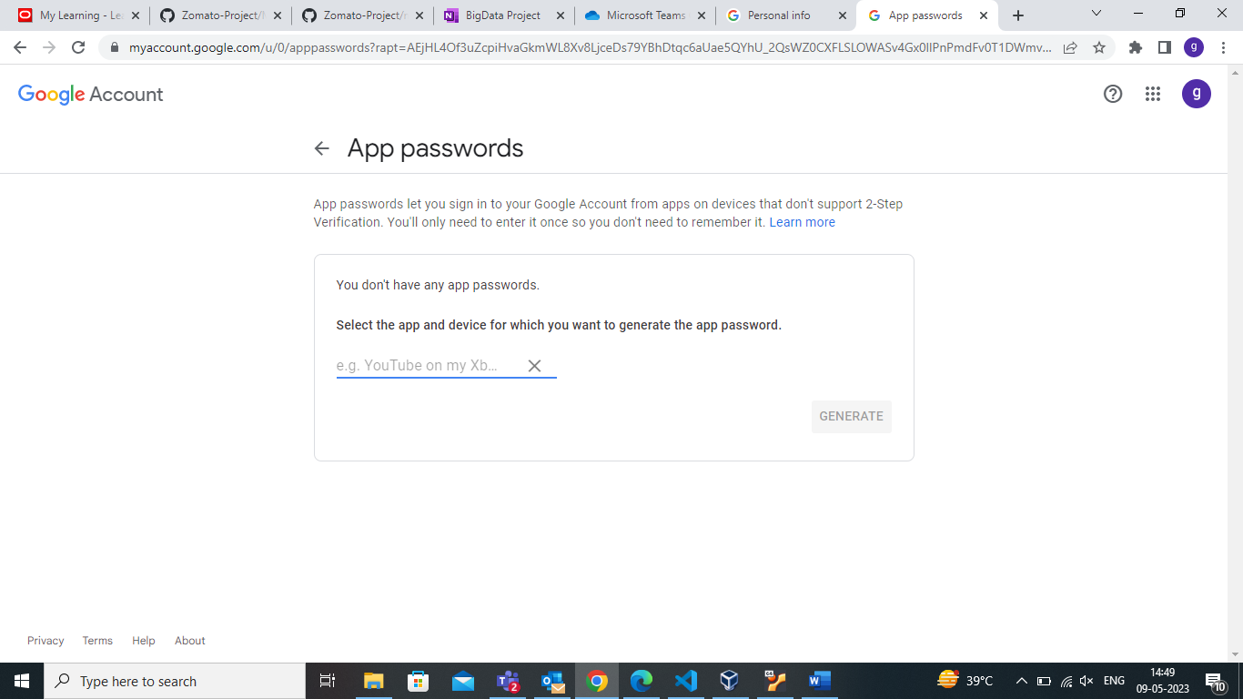

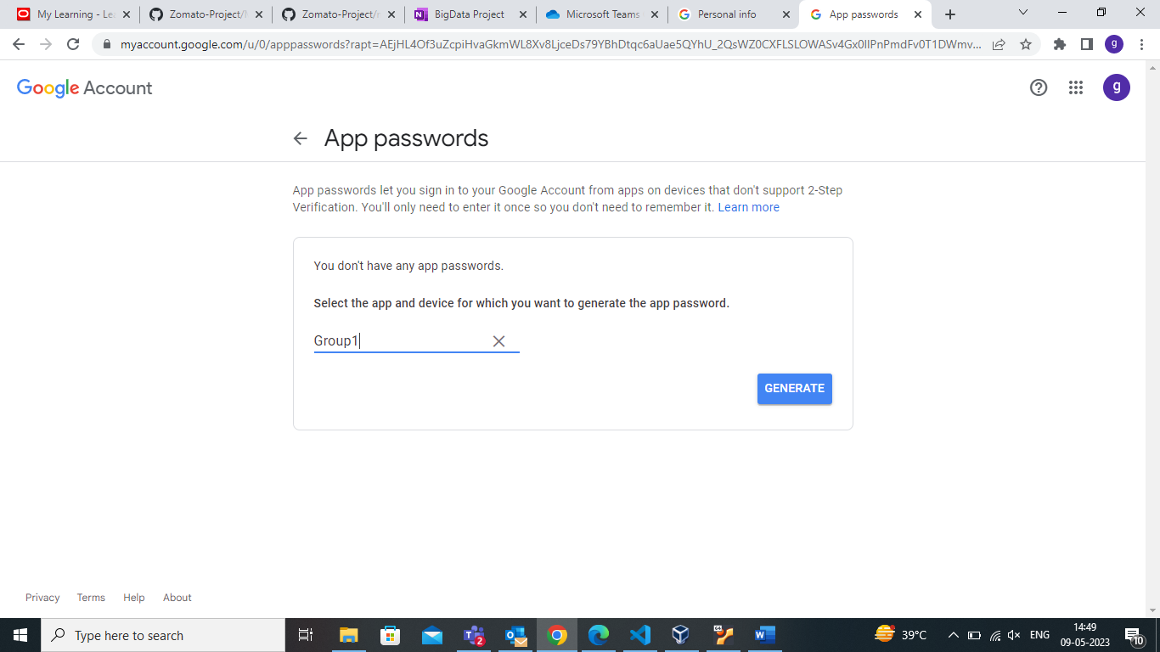

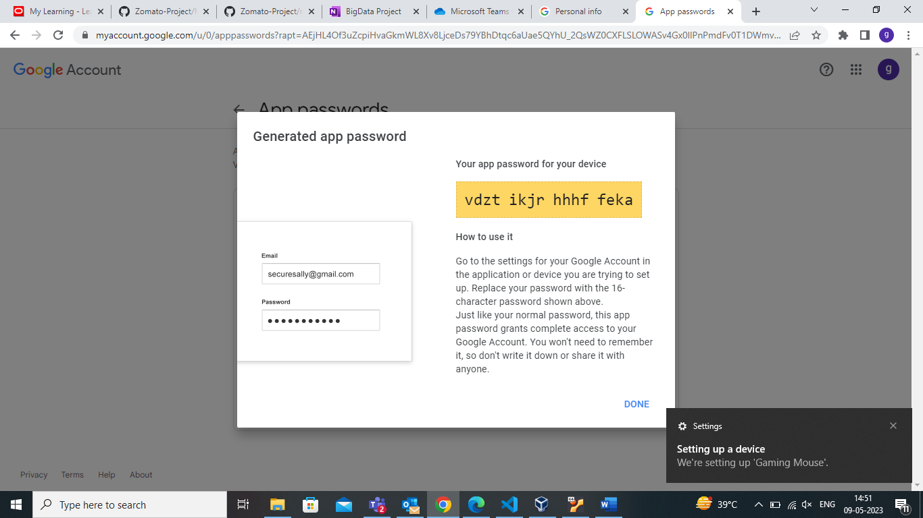

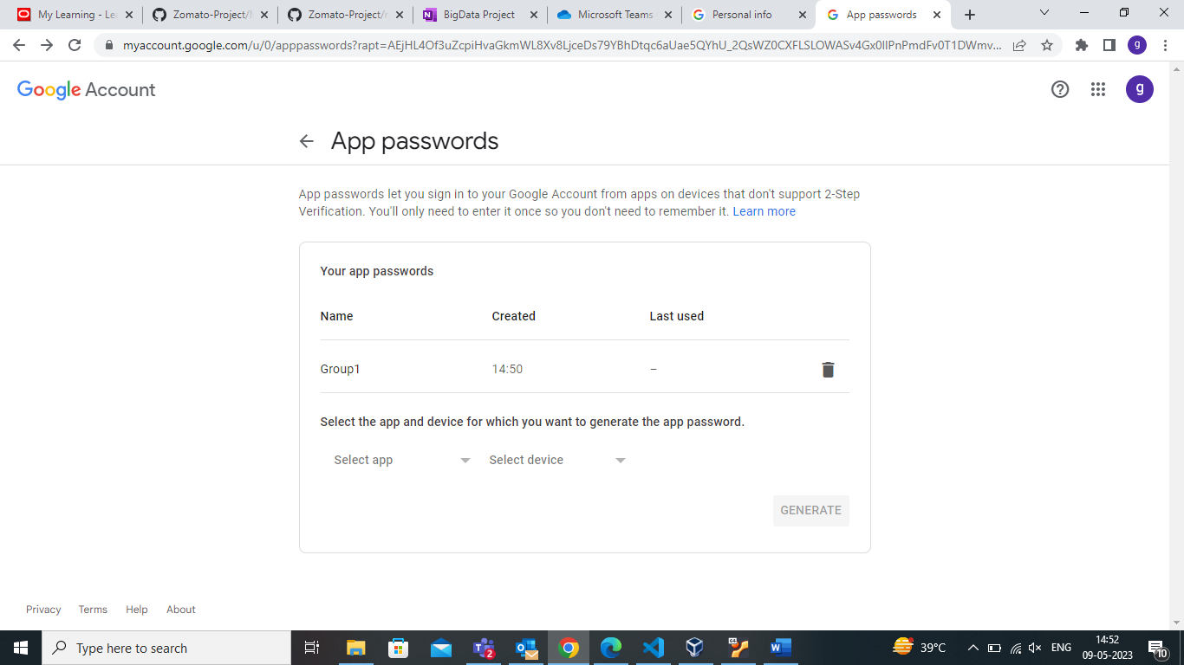

1. **Setting the configuration on linux**

Now open terminal and enter the commands below.

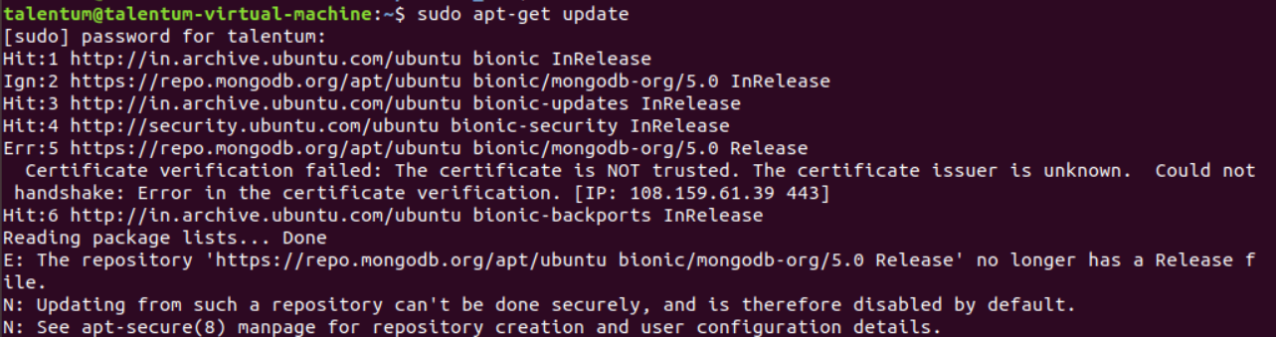

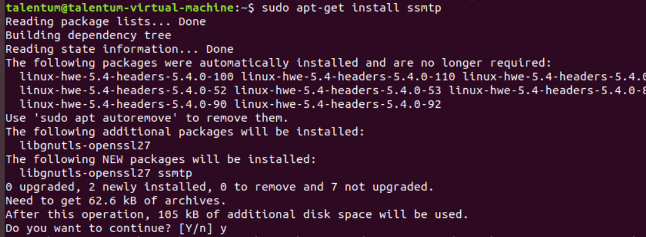



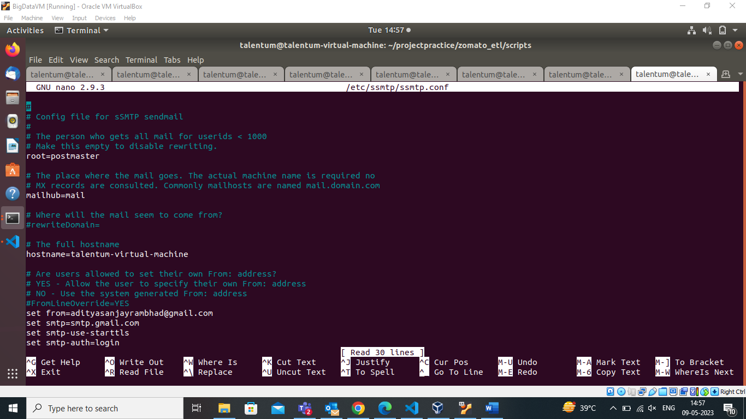

Make the following entry for the “mailhub” configuration>>

This page will get open. Make the required changes in the file that is the “mailhub” to smtp.gmail.com:587

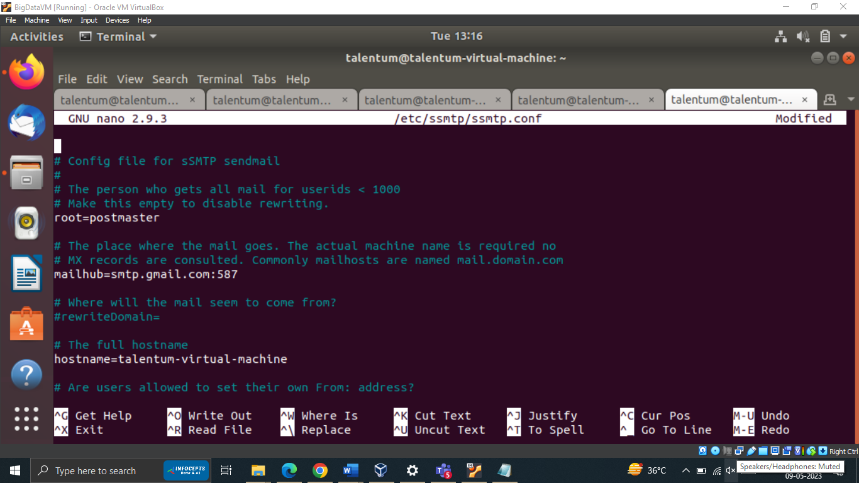

Enter the email address of the gmail account and the application password that was generated earlier. ***Note that this is not the gmail password. This is the application password.***

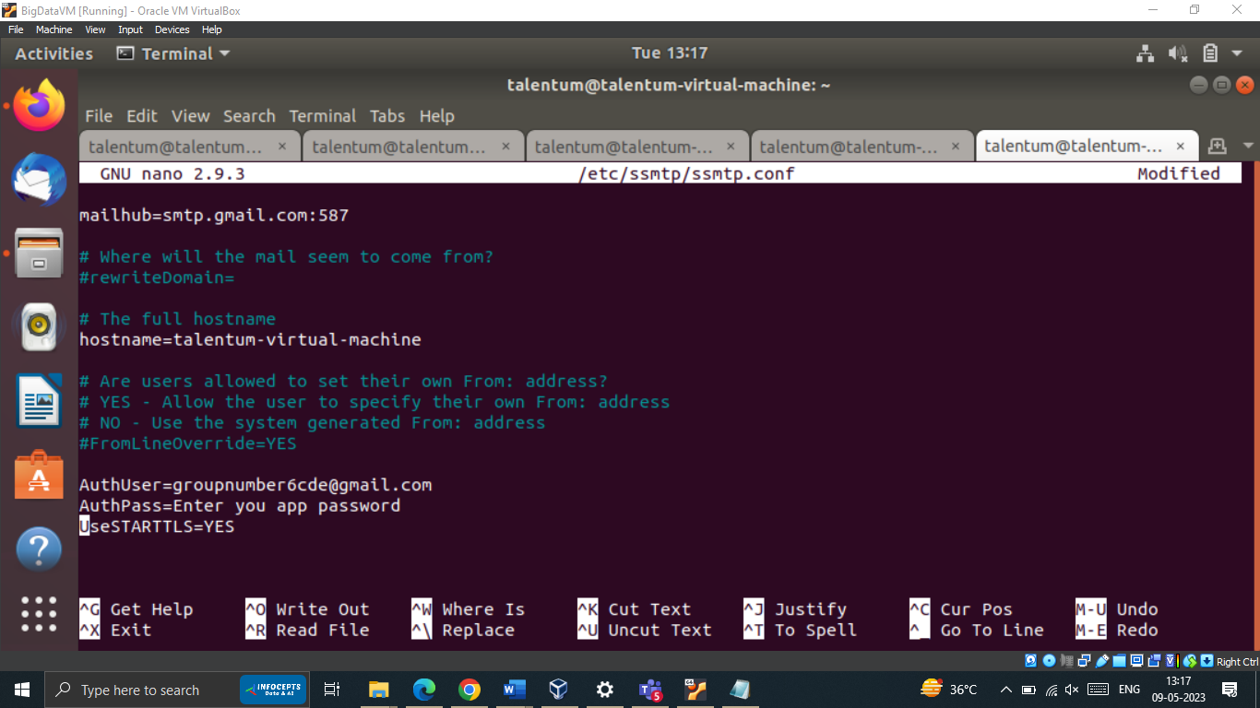

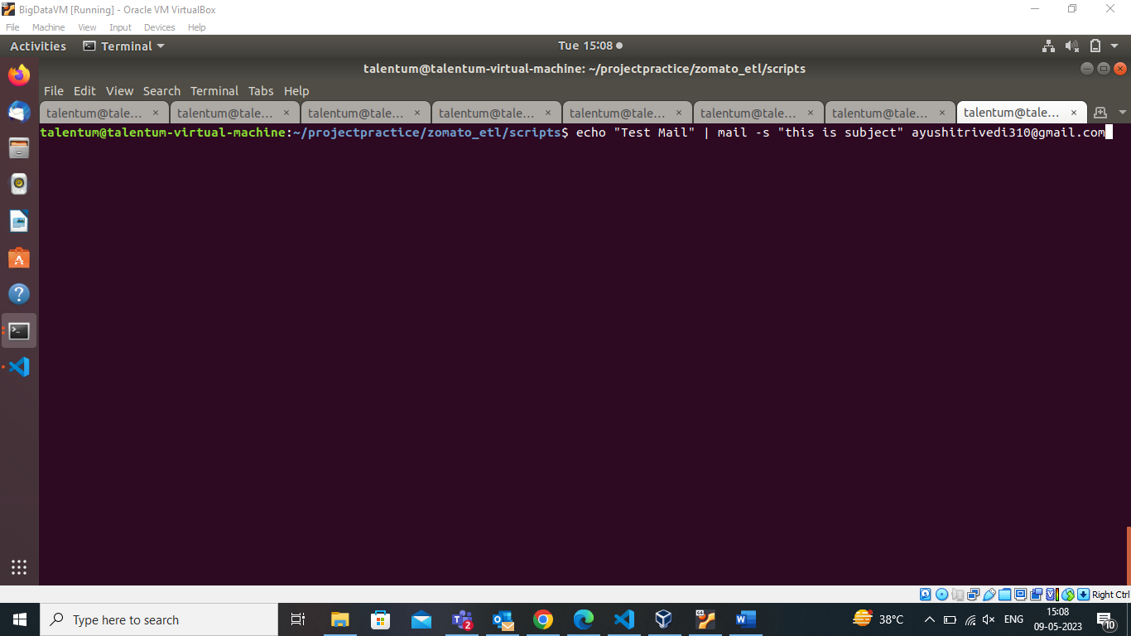

Check recipient’s mail. You must have received the mail as “failed”.

**References:**

[What SMTP port should be used? Port 25 or 587? | Cloudflare](https://www.cloudflare.com/learning/email-security/smtp-port-25-587/#:~:text=Originally%2C%20the%20Simple%20Mail%20Transfer,also%20used%20sometimes%20for%20SMTPS.)